**ICT Day Trade Routine**

1. go trough the economic calendar, we look for medium and high impact. We look at the time in relation to the killzones. The manipulation will generally be seen with economic news release. Look for pairs for the London or New York sessions that have a medium or high impact news event. So at 3am is a news event, so we expect a move to form at or around 3am in that pair, but we first look at the dollar index in step 2

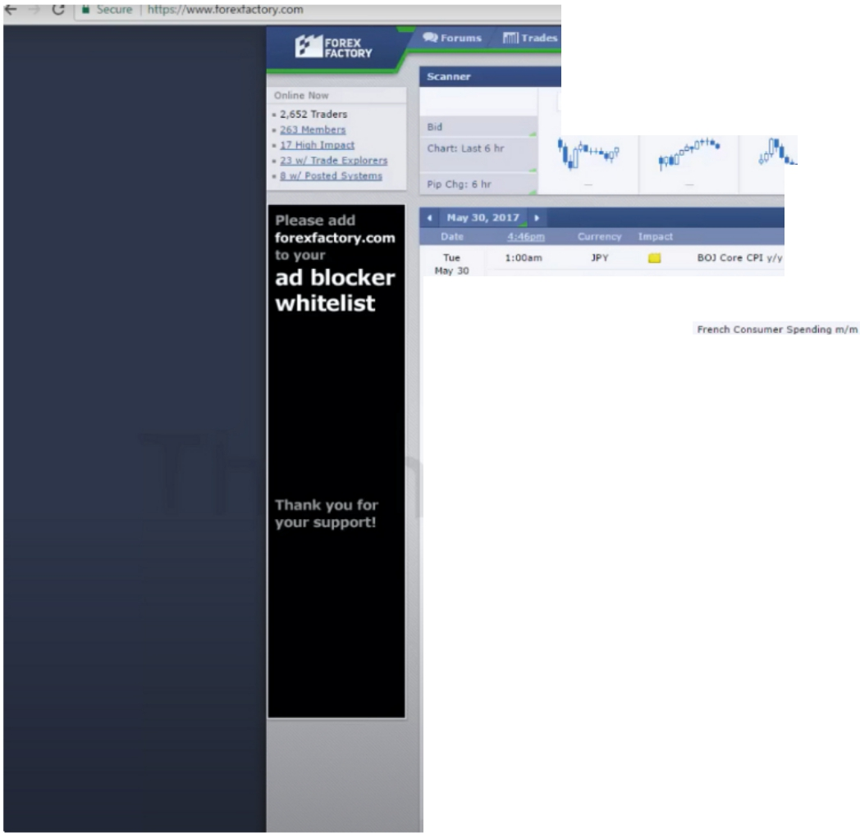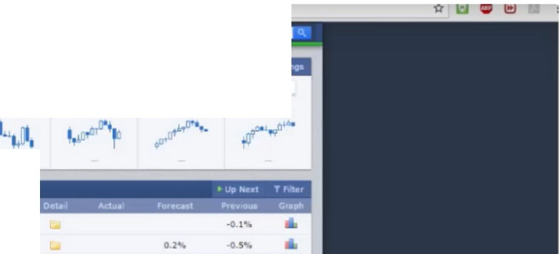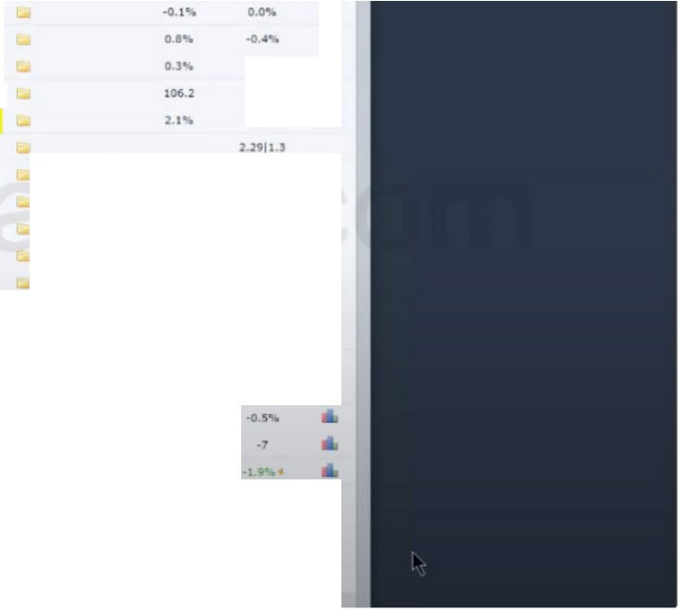

**[UII/UK> G11,1uso**

**USO/ WY**

**USO/Ctw**

**USO/CAO**

**#IUD/USO**

**NZO/USO GIi,,/ Jf'Y**

**UD"**

**EUR • <i•""""PreiiMCP!ffllM**

,..... ..

**106.0**

....

**0.),i,** ..

**CHI'** ■ **KOf'Ec-r.o,..,.!10r**

**_**

**6**

|  |  |  |  |
| --- | --- | --- | --- |
| **CAO** ■  **USO** ■ | **11:...,1"'"'**  **CON ,-Cl!'"° lncln** """' |  | * **10.711** ..   1, .....  **o.n. 6**  -GI ..... |
| **USO** ■ | **h,,_..IPfMll't"".,** |  | **o.o-,.** ...... |
| **USO** ■ | **C9C--ConfiMr,u** |  |  |
|  | **MCSho9,nce1n.s.u,1,** |  |  |
|  |  |  | **51.2 6** |
| **Cl'll** ■  **NZD** ■ | **11<><>·"-""'•-"'1"41**  **Al'IZ. ,_C..,,,..11<•** |  | **S;l.0** ..  110 ..  **o.,,** .. |

1. The dollar index

First thing is: Look at the last trading day and drag a trendline to the left until 60 trading days. If your broker shows sundays then you have to compensate for that, so you have to go further out

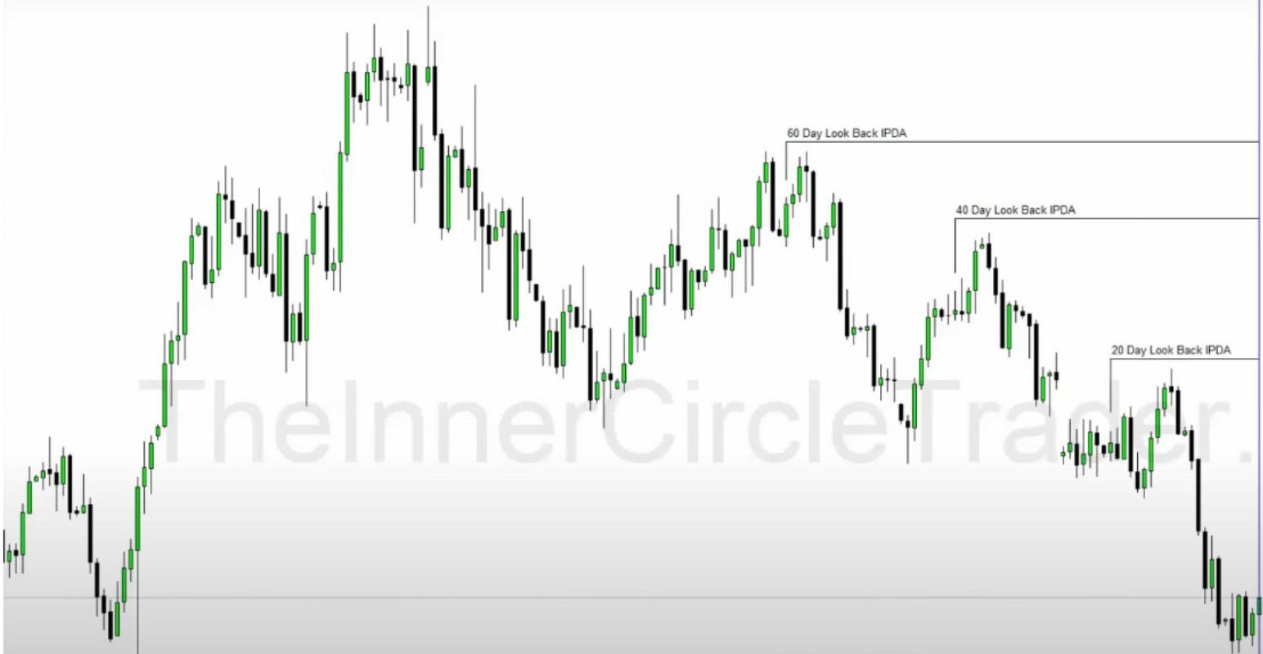

So now we have our ranges for fibonacci, and for our PD arrays. Initially our only primary focus is in the last 60 trading days. Count yesterdays day as day 1. Every new day we add a new day and we cut off 1 day, so its always shifting forward every day.

Every 3 months or every new quarter we anticipate a shift in market structure, a quarterly shift. We

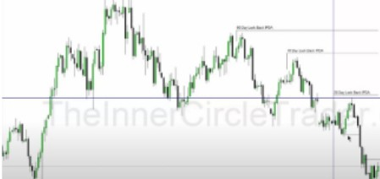receive it as potential trend reversal, but we do not always expect it. Its not end all be all. We just know that it can happen.



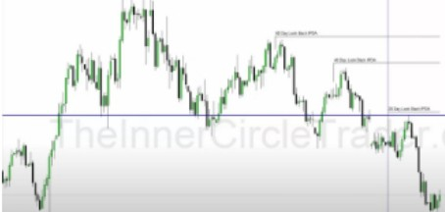When theres a gap and a breaker like that, we go with the breaker first because of the hierarchy. And we use the wick of the downcandle fo the breaker

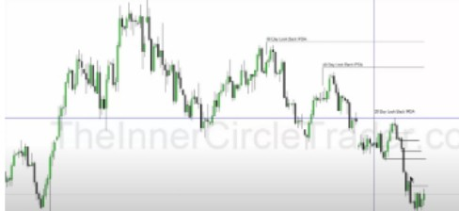

Notice how we use the highest upcandle and not the downclosed one, because the upcandle thats where the resistance begins for the FVG

So now we want to look at the last 20 days, where is our PD arrays? For daytrading you're going to operate in those last 20 days most of the time. If everything is already exhausted so everything is already been traded trough in the last 20 days then we look at the last 40 trading days

Now ask yourself are we in a premium or in a discount of the range, clearly at a discount of the 20 day lookback in this example.

Just because were in a discount it doesnt mean we can just buy it and expect it to go up, we have to look at where we are in terms of historical reference points. Even when we look at the last 60 and 40 trading days, we can see we're really in discount. Historically weve referred to the low with the long wick to the left, (Ignore the wick look at the bodies) price swept below that and we had a little move up, so were in a discount market with a lot of premium arrays we can trade to, and still keeping the bearish tone on the daily of the dollar

Now the discount arrays, he disregards the mean threshold of the first orderblock because its already been violated. So we have an orderblock, a propulsion block and a rejection block for our discount arrays

|  |  |  |  |  |  |
| --- | --- | --- | --- | --- | --- |
|  |  | **60D-,LookBKlilPO-.** |  | _::) |  |
|  | |
|  |

1. What is institutional orderflow for this market now

We see upcandles getting respected in the last 60 and 40 days, we see it break lows. So institutional orderflow for the dollar index is bearish. So preferably we go short thats the highest probability, but since we're daytrading we can countertrend trade that if we have the ranges defined in the form of a discount, so were already at an extreme and at a discount so we can possibly see a retracement, it doesnt have to but we can reasonably see it.

1. You would take the same elements and now apply it to the EURUSD chart

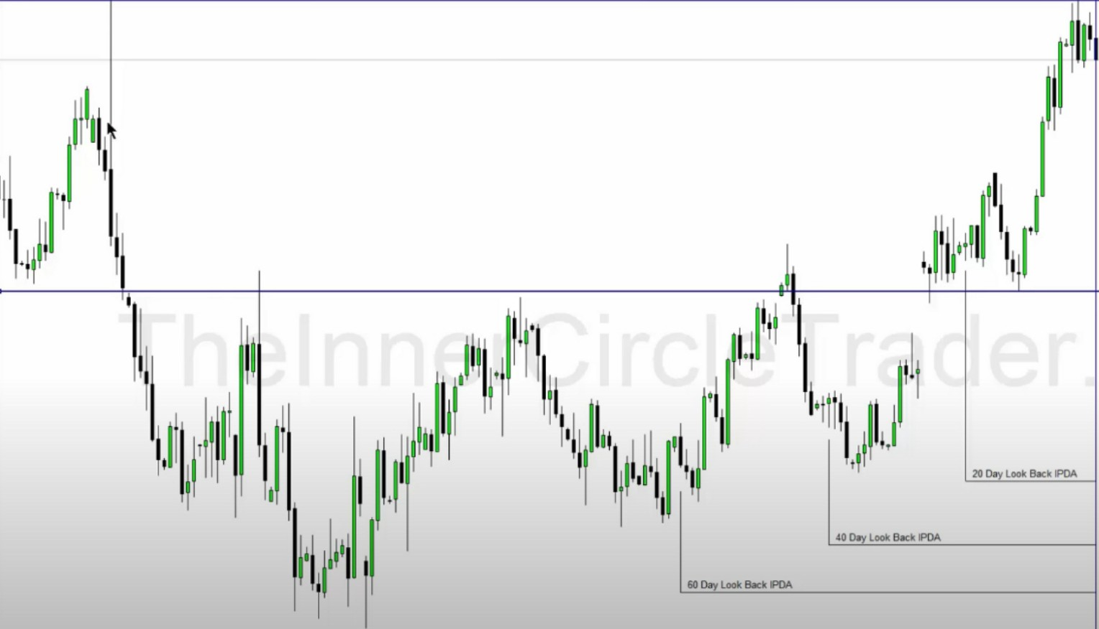

Were in premium, we also look back at the historical high because we have to have a macro perspective, we traded above that hold high to the left (Again ignore the wick)

You can see by focusing on the IPDA data ranges you filter out all the "noise" and you focus on what relevant now

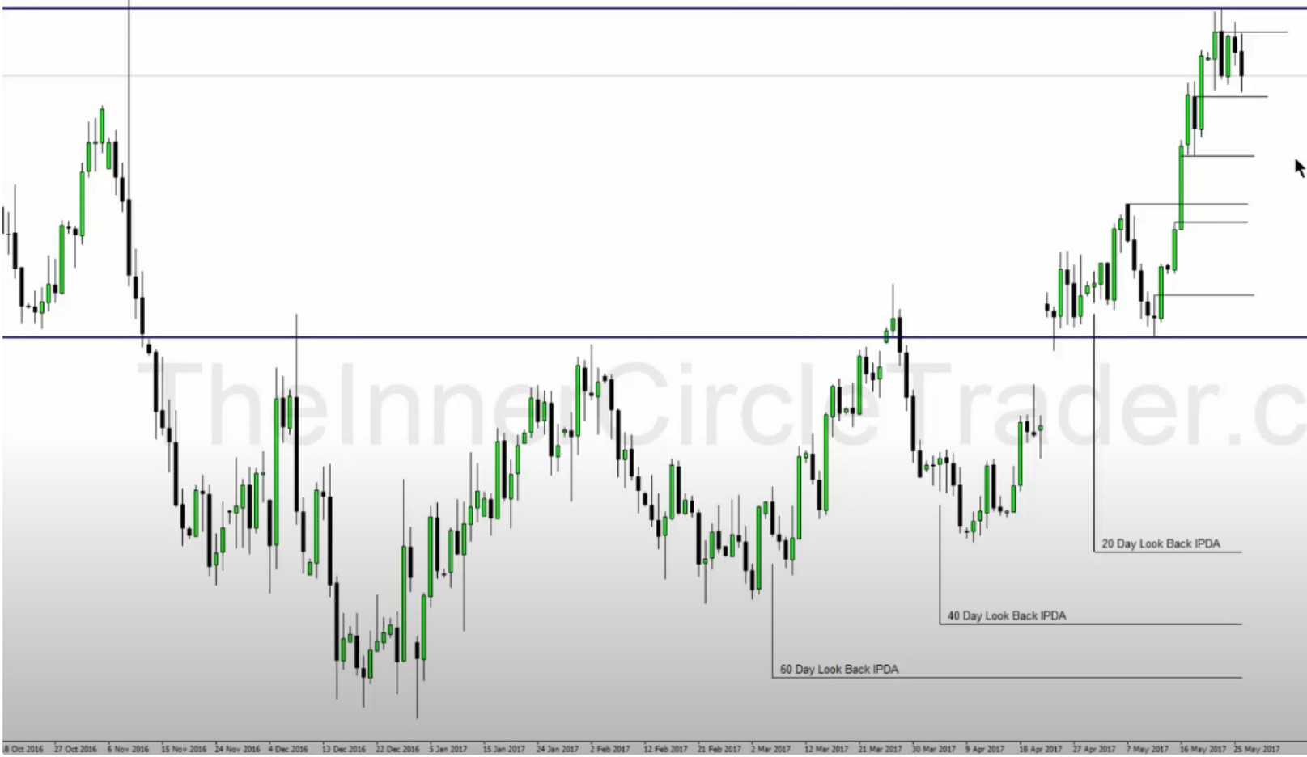

1. Whats the institutional orderflow of EU right now

Downclosed candles are being respected, highs are breaking. Institutional orderflow is bullish. We also have a big gap but we dont worry about that now since its so far away.

We have to be minful of the highest orderblock in the example, the open of that and the mean threshold, if the mean threshold gets disrespected were likely going lower into the gap. Because were in premium ICT doesnt use the high of the orderblock, its not as sensitive as in discount

1. Drop into a 4h chart on EU

Were looking at signs that price wants to retrace a bit to do an offset accumulation to go higher

If we know the daily institutional orderflow, the first thing on the 4h we do is look for reasons for price to take it down to accumulate new long positions. So that price will drop into a short term discount market like in the example below of the short term range

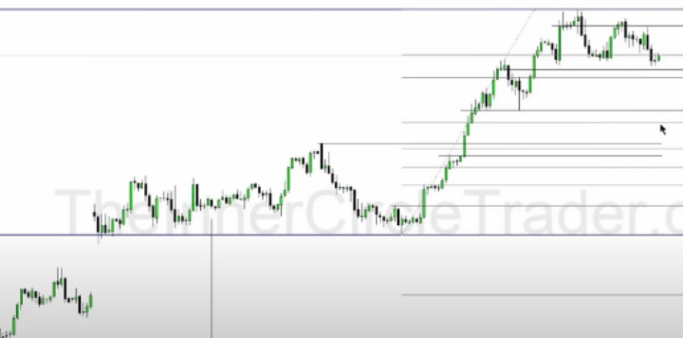

'..i:

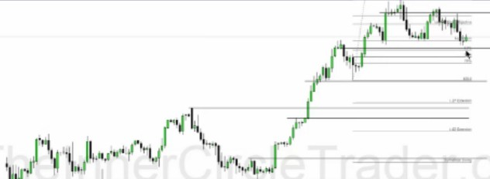

Short term range Total range

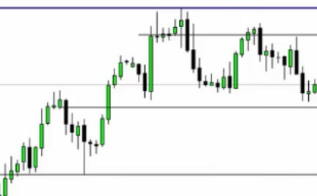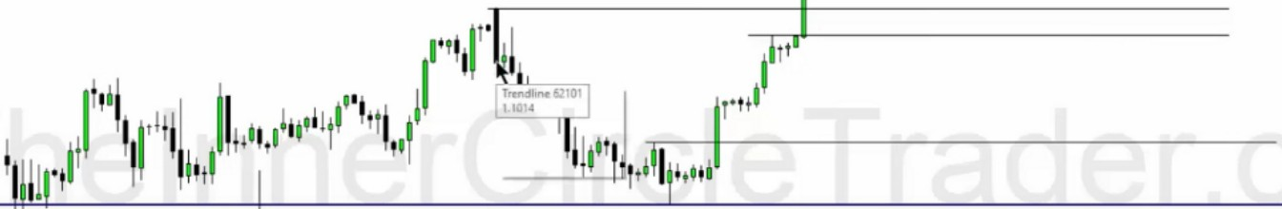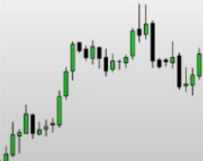

**200eylllOII.BKlr.f'OA**

Should we break the orderblock above then were likely going to that old high

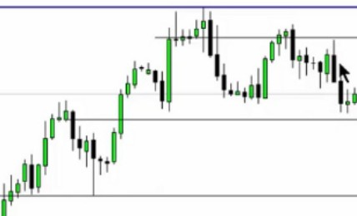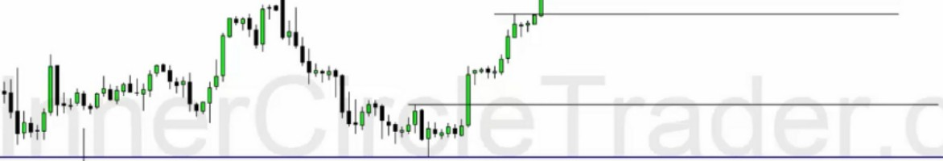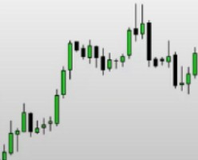

1}**l** 11,,1'1

**t,11**

20(Ryl.ooltBacklPOo-.

If we go trough the mean threshold that would invalidate the idea of bearishness and theyre going to run it higher and once we do that we're going to be looking at the last 2 downcandles as a potential bullish orderblock once we trade trough the last upcandle

Thats how we map out 2 scenarios bullish and bearish.

We have to justify the daily institutional orderflow being bullish so we look for arguments that would say: If price where to drop down why and where would it drop down

Start justifying and looking for scenarios as to why the continuation of the HTF institutional orderflow should be the case, but if you cant find entries for that or not yet, then think okay were in a premium maybe the market should go to a short term discount, but if it takes out specific discount arrays then we're probably changing tide and its going to want to go lower on a more interdmediate term basis vs short term basis

1. Drop down to a 1h chart and do the same thing

11IIL11,1i!l'01

11·1·1

11!

111111·1,,\ 11

1111

11,,1

I

1

111 1,,1,,

1

1

111"l1''lj l!,1

111 1l11h11111

1 1

I

111i11li,1

I'

111!''11

11

11I11

II

-•• ,,

*r'*

1,1111,

j

*(*

1

\1il"'ii''

,,....,11••-· "",. ,. """'- ,, """ *_u_,_11_,,_11_,_n n..._,,,.n ....* - ,. .... _,._u•10--•--a. ,,1•• -•--•-·•-•--

·-

··--

,...

c,m

11111

u•

..

,_

LIi.

.:,

11111

"-

"-

· ·

,_

,_

·,·-

,=

**1!**

I

**,11!1 1**

lit

,-

·-

* -Lll71L11.1ll71LIIII

We look for confluences of PD arrays that overlap with one another and justify that if its going lower, is it just going lower for them to buy at a cheaper price to go up again in the direction of HTF

institutional orderflow or is it to go lower lower. We cant guess that yet dont think you ever can know that, were looking for probabilities.

Right now price is in consolidation, so we could be in a consolidation to build up the open float and a large liquidity pool to eventually take the SSL and then go higher and if theyre doing that, where are they doing it

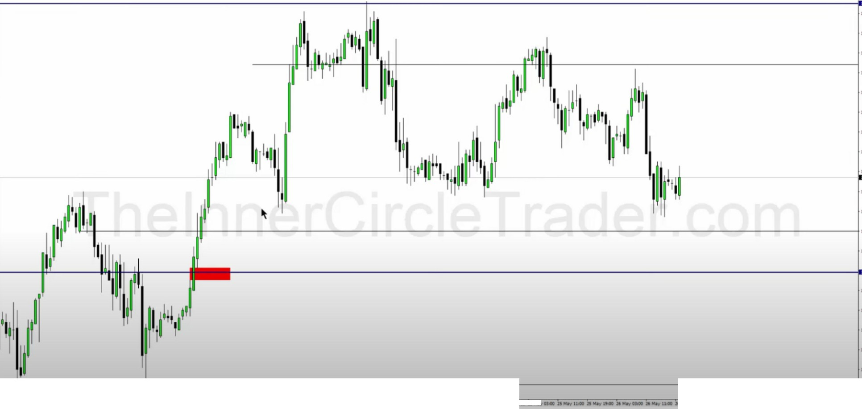

**-,a,,,, _1,--u -11--• -••--11** -n--n -ll **uall n,an--u ,.,.n-na11 -11** 1 11-• .,.

Now we have a convergence of 2 overlapping discount arrays and its below the sell stops and inside the daily orderblock

Now how do we use this information? IF price trades down to that level we want to be in a 15m timeframe and look for our standard deviations, in the form of CBDR, flout and asian range standard deviations and we want to project them above and below the market place giving us potential targets and places to look for and also we want to be looking at the opening price at O GMT and MNO and if were expecting bullishness then at the openings we would expect a small decline on a 15m chart

By having that protractionary stage at MNO or O GMT, we would expect at this level or very close to it to be a buy for a daytrade. That expectation would be for London and if London fullfills the expectation then we would expect a continuation in the new york session

We could also see a new york sessions reversal

Dant think like: 'This is the only thing that can happen" Because thats not true, a lot of things can happen but generally if you think in generic terms, bullish or bearish then theres only a few templates you can use based on the day of the week it trades down to that level time of the day etc

If we run down and run back up and see evidence and willigness that price wants to run trough premium arrays, if it does then that means the drop was a stop run and insitutional ordeflow on the daily will kick back in and we'll probably see more bullish prices

|  |  |  |  |
| --- | --- | --- | --- |
|  |  | |  |
|  | |  |
|  |  |
|  |
|  | |  |
|  | |  |

If price fails to long at the red level, then re consider and zoom out a little bit, we could see an intermediate pullback to the old high, those EQLs below the red level would be a target for expansion to the downside NOT to buy from tho, then we would expect it to go lower to the old high. Then we would wait for a rally up from O GMT and or MNO and look to sell from a premium array and short on that on the basis of a 15m/5m chart. And then once at the old high it could be an opportunity for the HTF daily institutional orderflow to kick back in again and trade higher

Theres a formula

Formula:

Economic calendar, framing the time of day what influences on what pairs are we going to have for London and New York - Analysis baseline on the dollar, determine IPDA data range, look at the PD arrays, consider the PD array matrix, determine HTF institutional orderflow - Breakdown of the pair thats has the news driver for that session so we can anticipate some measure of manipulation and think of the weekly templates, what day will it hit that level? Consider the weekly templates

We always look for daily institutional orderflow to give us our directional bias, we always look to continue in that direction. But there are times where we may need to consolidate or retrace a little bit so banks can buy at a cheaper level. But we dont predict tops and bottoms, because theres large banks and funds clearly buying and supporting the bullishness so if thats the case, going short is just dumb.

So in short summary:

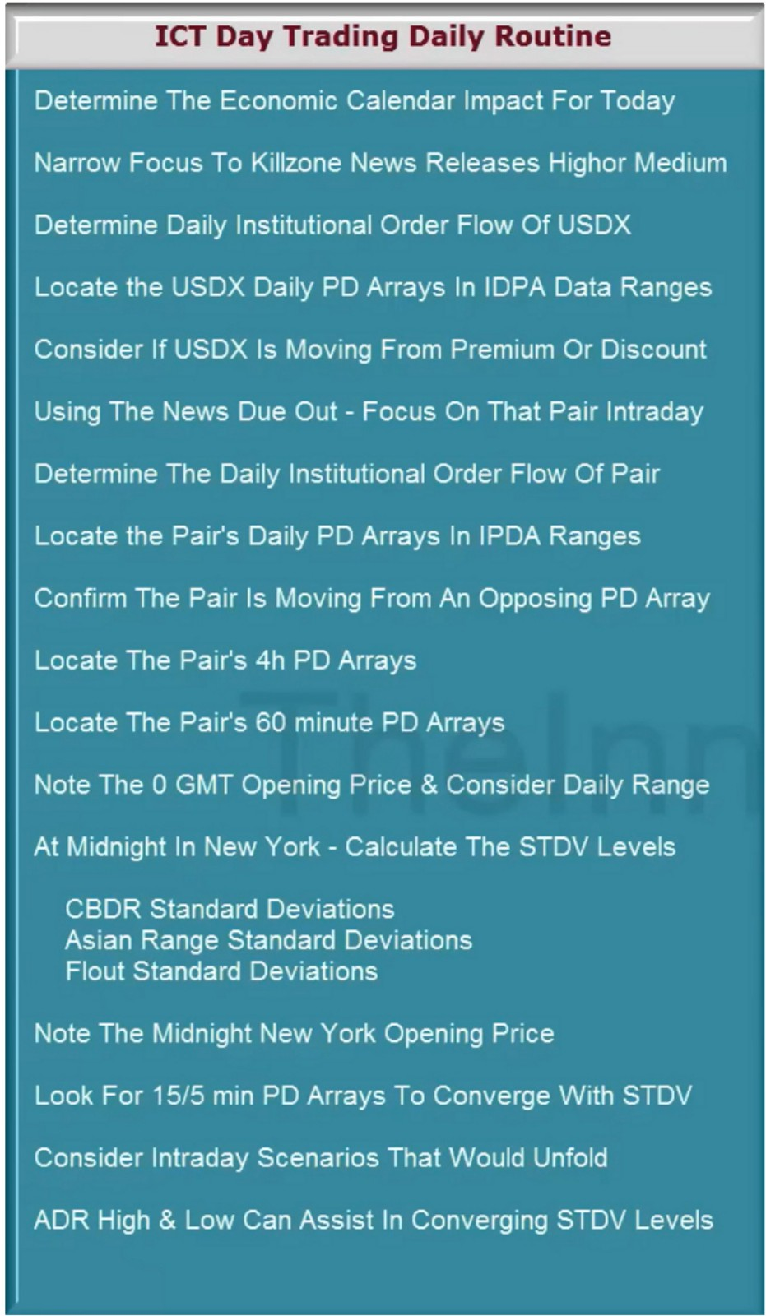

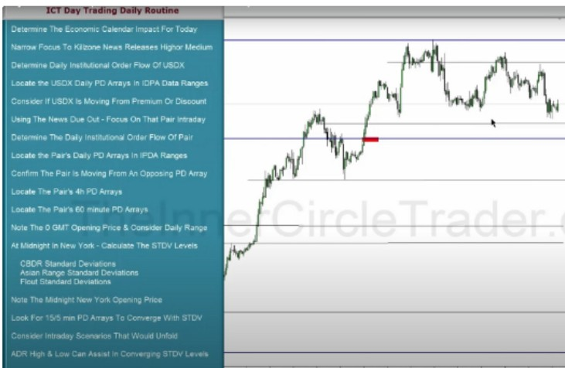

If theres a confluence of STDV levels, ADR and a PD array on a 15m, 1h or 4h PD arrays basis then you know theres a high probability for price to want to expand higher or lower to those respective levels. When ICT is picking highs and lows and gets really close to it, this is the procedure he's using, nothing secret no secret sauce. Its the work of this and looking at the weekly and daily templates. If were bullish theres only so many bullish templates to outline so we would look for templates to support the idea, start with monday low of the week, if monday doesnt give enough evidence then look for tuesday low of the week if tuesday starts to trade up then we know wednesday is probably going to be a good buying day to scout longs in and we can do that all the way up into thursdays new york open that is when we can expect the weekly high to start to form, it doesnt have to! If thursday continues higher then we anticipate profit taking on friday so try not to buy on friday so either stay on the sidelines or look for currencies that would support the idea for reversal scenarios

When we have that weekly range or institutional orderflow ideas as weve outline here in this teaching, once thats incoorporated into your analysis you NEVER want to go against that for the framework of high probability, stay inside that framework. In other words if daily institutional orderflow is bullish we want to primarily look for reason to justify going long. That means you're not always going to get a daytrade buying in that enviroment there will sometimes be a consolidation or a retracement and theres nothing worng with that.

Daytrading is not every day trading and scalping is not every move, every fluctuation intraday is not a scalp

Once we have the STDV levels, ADR, in line with our expectation of institutional orderflow or where we think the bias is going to be based on that daily and 4h. Then we use the weekly template to justify what the weekly range may be and that put the highest probability in our favor, once we have that we go into our daily routine: Is it going to be an open down low of the day first then upclose or is it going to be a consolidation druing London then trades down and new york creates the low for a buy opportunity for a new york market reversal then trades higher? Justify and frame the idea.

Youre never going to knwo what weekly template is going to unfold before sundays open, you know you have a few of them that are in expectation of unfolding.

It helps you train your eyes to look for scenarios where these would unfold, but more importantly it gives you the context to frame your trades, its the plan your trade and trade your plan stuff but if you dont know what that means conceptually with ICTs stuff, its just simply going trough the motion of: are we bullish or bearish longer term and on the daily? If were bullish, were going to be focusing on the weekly range to unfold in a bullish capacity so look at the weekly templates and look each day of the week as to, where are we in this day of the week to unfold that weekly template? Even if you only get 1 portion of that template to unfold and you make profit thats enough, dont try to do it every single day

Then when we look for individual day scenarios: are we looking for scenarios where the london session is consolidation then new york creates the low of the day, or do we create the low straight off the jump at O GMT? Or are we going to see the classic buy day at MNO london LOO

You dont know for certain what will happen

If you look at every session, first at O GMT you may take losses and then you have to look again in london, this creates overtrading. So if youre willing to leave O GMT and focus on MNO what ICT does then use the open at MNO and if were bullish we want to see a drop below MNO to some measure of STDV levels, CBDR, flout or asian range and to a discount PD array visible on the 15m timeframe that may converge/overlap also with a 4h or 1h discount array. By doing that it helps with confidence to nail down the low of the day

If it happens in london then we can have the confidence to buy all day long with no fear, using the general rule of thumb that price will drop 33% down and make a 100 pip range upclose that also helps framework the precision

Then we can target the STDV levels, flout, CBDR and asian range projections that overlap with ADR and an opposing PD array either on the 15m, 1h, 4h and or daily

This is our routine for daytrading and scalping, systematic and generic form. There are still choices you have to make, you need to elect to do 1 thing over the other, and thats a step by step process. Theres no unicorn where you do the same thing every day.

This routine is what ICT does every single trading day

Even when youre wrong and when you take a loss, that feedback is empowering and its giving you insight. Dant view the loss as a bad thing. Smart money doesnt view a loss as a defeat, its a premium paid for a greater insight.

We want to align ourselves with the people that know the inside stuff, so if were wrong we immediately know what theyre doing. Wait for another setup and have patience again, dont rush in.

ICT has done this so many times, he can do it really quick, he already sees it, he has the experience

It will become second nature

Watching price action is the best thing you can do, it builds something in your brain, experience is the most important

The best trades are going to be in sync with institutional orderflow You have to grow into it, you cant be the best straight out of the gate We're blending time an price scenarios with the templates

If monday is an USO bank holiday then tuesday generally becomes what monday tends to be, a rangey day